Inclusive practice in Music Education Hubs – where are we now?
A report exploring how Music Education Hubs are changing the way they work, and what needs to happen next.
November 2020
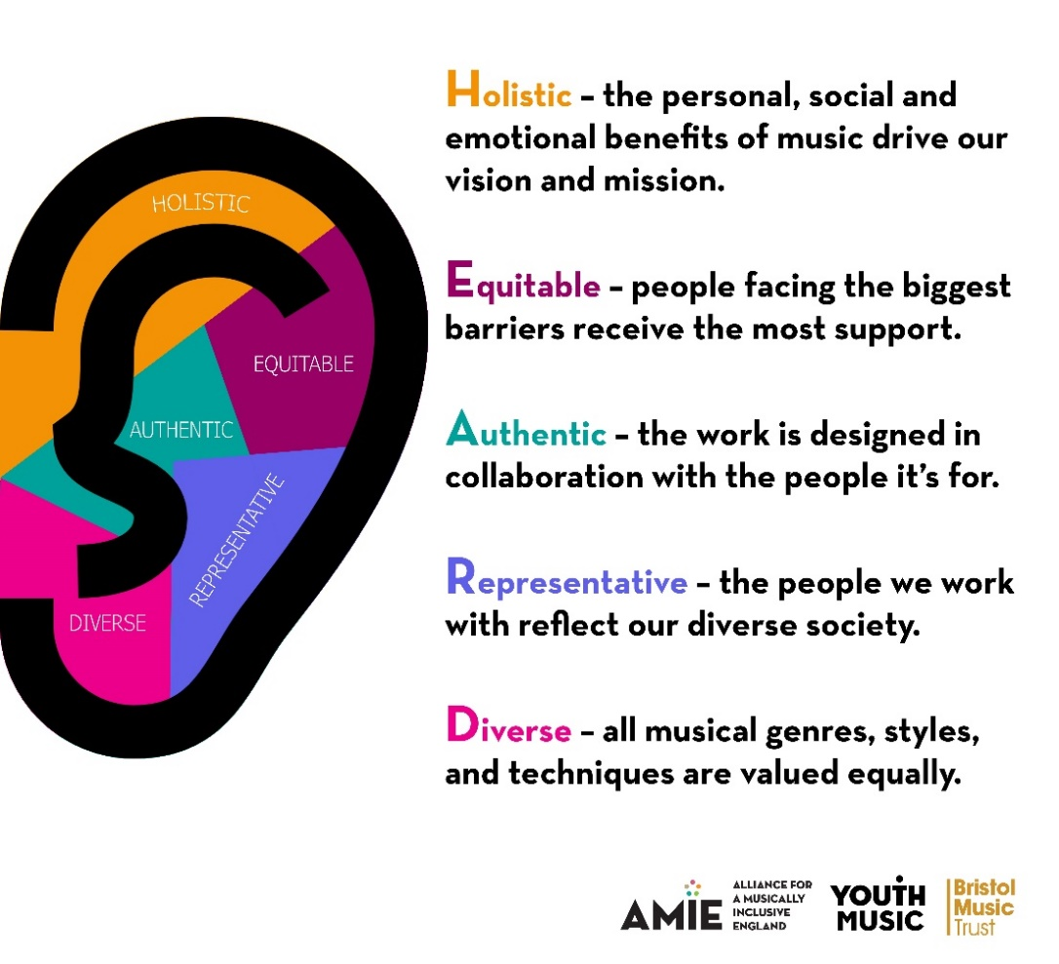
Picture: the HEARD inclusion principles developed by Bristol Music Trust working alongside Youth Music and the Alliance for a Musically Inclusive England.

Background to this report
Improving inclusive practice in Music Education Hubs (MEHs) is central to Youth Music’s ambition to make music education more accessible and inclusive. In addition to funding inclusive programmes through Fund A and Fund B grants, there are two Youth Music programmes that have a more specific focus on this goal. They are:
- The Fund C programme. In 2020/21, 13 Fund C partners are delivering their third year of funded activity.
- The Music Education Hubs Development Fund, which launched in 2019/20.
Fund Cs work to increase inclusive practice and improve the quality of music delivery for children and young people through forming strategic alliances with MEH lead organisations. The Fund C organisations work together and alongside Youth Music through the Alliance for a Musically Inclusive England (AMIE). The alliance is a movement for change in music education, promoting equity and helping others to do the same. In 2019/20 an inclusion resource hub was established on the Youth Music Network as a means of sharing practice within and beyond the AMIE network.
In 2019/20 we launched the Music Education Hub development fund. The fund was targeted at those music education hubs that had least benefited from Youth Music funding. 22 grant awards were made in March 2020, supporting MEHs to improve their inclusive practices. Youth Music is currently working with MEH grantholders to adapt their plans and share practice as their programmes evolve. Decisions on a second round of Music Education Hub Development Fund grants will be made before Christmas.

Inclusion in music education - where are we now?
2020 marks the end of the first phase of the National Plan for Music Education. A timely moment to reflect on distance travelled with regards to inclusion in MEHs, and offer recommendations for the next phase. This report draws on data from a range of sources. This includes Fund C grantholder evaluation reports and information gathered through the Music Education Hub Development Fund and Youth Music’s wider funding portfolio.

Increasing prioritisation of inclusion by Music Education Hub lead organisations
When considering how inclusive practice has improved in music education hubs, it is important to think about inclusion as a process of change. It is not an end-point that can be achieved, rather it is a means of continuous and incremental development. Advocacy in the first round of Fund C delivery (which ran between 2015 and 2018) was focussed on winning hearts and minds and championing the importance of inclusion. In many MEHs, this argument has now been won.
The positive actions taken by MEHs to improve their inclusion practice has enhanced their ability to cater for the needs of young people facing barriers. According to our annual stakeholder survey, 47% of respondents now rate hubs as ‘above average’ compared to 32% in 2016.
Inclusion is a higher priority than it’s ever been, with many Hub Leaders positively embracing the need for change and engaging in collaborative working to help them achieve their inclusion goals. There are now a significant number of hubs that have specific inclusion plans (or equivalent) with related key performance indicators. Clusters of MEHs in Yorkshire, East of England, West Midlands, South West, East London and the South East are also working towards regional or sub-regional inclusion actions. Through collective action, they can achieve economies of scale with both expertise and resource.
Embedding inclusion into organisational strategy guarantees resource to deliver inclusion aims alongside accountability of progress. Having a series of inclusion projects that are not considered as part of a wider strategy means that the good practice developed through those projects risks being siloed. There is also a risk that activities required to bring about transformational change (e.g. workforce development, using data to identify gaps and measure progress, diversification of the workforce, embedding inclusion values into the culture of the organisation and its practices) are not fully considered.
Shrinking budgets, along with budget uncertainties towards the end of each financial year (as MEHs await confirmation of their settlement from the DfE) pose risks to the continued progression of inclusion. Embedding inclusion in organisational strategy (for example the business plan or an inclusion strategy) will help to mitigate this risk. It also ensures a strategic approach by outlining what needs to happen to ensure continuous development, considering how different activities feed into each other to achieve a higher goal and embedding regular reflection and monitoring. Any MEH that does not yet have an inclusion strategy should consider developing one, bringing in external expertise where appropriate.

Improved opportunities for young people to influence MEH practice
Many partnerships are working together to ensure young people are genuinely heard and able to affect decision-making in MEHs. Having youth voice as a focus for the 2019 Music Mark conference was an important way of bringing the practice of youth participation to a widespread audience across music education
AMIE partners undertook youth consultations and established new youth forums, ambassador programmes and young producer projects. These provided evidence that MEHs were listening to young people’s feedback and developing new activities as a result.
There is scope for this to now go further by embedding more young people in MEH governance and decision-making; expanding the range of youth voice and participation activities in the hub; and systematically embedding young people feedback processes more widely.

More diverse offer and improved range of young people taking part in activity
Fund C reports progress in the range and genre of musical offer, and in communication of this offer to reach new groups. Digital production and tuition, accessible instruments, more diverse repertoire, inclusive ensembles and working in new community and youth spaces have all helped towards this outcome. This progress is hard to track systematically using published data, however the annual Music Education Hub annual report does include the number for ‘SEND inclusive ensembles’, which has increased from 582 in 2015/16 to 896 in 2017/18.
This increase reflects the work that has taken place to improve access for Disabled young people. Amongst the AMIE partnership, training has led to better understanding of the barriers faced by young disabled people, prompting several MEHs to roll out training to their whole staff teams. One partner offers bursaries to Disabled people to undertake the Certificate for Music Educators. Such activities have led to small increases in Disabled people in the music education workforce, but they remain massively under-represented.
The Black Lives Matter movement in 2020 has increased awareness of the lack of diverse repertoire in music education, whereby the formal curriculum features predominantly white men. The lack of diversity within the composers of set pieces offered by music examination boards should not be ignored. As valued customers, MEHs could help put pressure on other parts of the music education ecosystem to become more diverse.
MEHs have the power to offer a more diverse and relevant music curriculum. There is scope to embed more digital, composition and songwriting in activities for young people in whole class, 1:1 and ensemble tuition. And to align the curriculum to the opportunities in today’s modern music industries. Many existing ensemble set ups stem from models that were forged decades – and in some cases centuries – ago. This excludes many young people, as participation requires years of musical training. Hence the establishment of ‘inclusive ensembles’. Which begs the question: why can’t all ensembles be inclusive?
Building on the disruption to normal working practices as a result of COVID, it feels time for a re-assessment of a MEH’s offer to young people. Young people themselves can play a vital role in ensuring the MEH’s relevance, with opportunities to engage them as leaders, promoters, administrators, and policymakers. Not only would this help them develop important musical and music industry skills, it would also bring more youth voice into the Hub, and widen the pool of young people it engages with.

Development of knowledge, understanding and skills in inclusive practice amongst the workforce
A range of inclusion-related training activities now regularly take place, from one-day introductory sessions to longer courses including the accredited Certificate for Music Educators. Other workforce development activity includes peer teaching (between Hub staff and Fund C music leaders), shadowing, teacher forums and networks. In some hubs a cohort of ‘inclusion champions’ are developed, who then cascade learning amongst their peers.
Grantholder reports presented evidence that knowledge and understanding of inclusive practice had improved amongst workforce practitioners, and they were able to apply this in their practice with young people.
Two AMIE organisations collaborated to develop a conference framed around the HEARD principles, which helped one practitioner to “think about inclusive practice on lots of different levels.” This is an important point, as equality and diversity conversations within music education can sometimes be reduced to just ethnicity and disability.
With many of the AMIE organisations developing one-day introductory inclusion training for their local MEH partners, there is scope for greater shared learning and approaches. For example, the agreement on a set of fundamental principles to inform the syllabus, and sharing delegate feedback to identify which approaches are more effective.

The Music Education Hub workforce
If inclusion in MEHs is to improve, then the drive needs to come from the top. This is reflected by the Hub leaders who are involved in the AMIE partnership. They (like many of their peers) are passionate and active inclusion advocates. There are lots of opportunities for Hub leaders to network with their peers, sharing learning and providing support. This happens through their AMIE partnerships, and through Music Mark regional networks and national events. There are also lots of middle managers and indeed Music Teachers involved in the work, but their opportunities for networking and peer support beyond their own MEH are far more limited. This is something that should be considered moving forward if we want to bring more resource and expertise into the AMIE movement.
MEHs have an awareness of how “deeply entrenched some of our more out of date practices are”. Whilst many Hub Leaders are fully brought into the inclusion agenda, this also needs to filter out across the workforce to achieve real cultural change. Organisational change will always create feelings of uncertainty and resistance from the workforce. Addressing the human side of change management is vital, but can often be overlooked in an organisation’s strategy and operations.
Any wholescale change towards inclusion must consider ways to bring the whole workforce onside, and there is scope for more learning and development in these practices. Sharpening some areas of internal communication could provide some quick wins, and tracking staff feedback and motivation could help inform future priorities. Particularly in relation to important conversations around racial inequality, care needs to be taken to navigate difficult conversations in a challenging yet safe and productive way. If inclusion is about fostering a sense of belonging, we should not forget that this applies to the workforce as much as it does to young people.

Workforce diversity
Core to any inclusive service provision is the need for it to be delivered by a representative workforce, and with this comes a need for greater diversity in the workforce. This has been increasingly recognised by MEH leaders over the last couple of years. The Black Lives Matter movement and Youth Music’s Reshape Music report have further highlighted the urgent need for change.
Partnership models between MEHs, Fund Cs and other MEH delivery partners often lead to a more diverse workforce for the Hub overall, but this doesn’t always impact on the wider staff teams directly employed by the Hub lead organisations. As well as a music teaching workforce where young people can see themselves represented, change also needs to happen at the leadership and governance level.

The will to build a diverse workforce is often slowed by a lack of knowledge about ‘what works’, with few models of effective practice that others can draw on. There are a handful of MEHs across the country that are known for having a more diverse workforce, but what they did to achieve that has not been widely codified and shared. A quick online Facebook poll undertaken in November 2020 asked Hub Managers the question “do you require your teaching staff to have a teaching qualification?”. 100% of the 44 respondents said no. Whilst this is not representative of all MEHs, it shows that good progress has been made in recent years to adjust the minimum entry requirements and therefore widen the potential pool of applicants. Whether this has translated into an increasing number of applications and recruits from candidates from more diverse backgrounds remains unknown.
Some MEHs that are still part of their local authority have reported that it is more difficult to adopt new approaches due to a lack of autonomy over their recruitment practices.
In terms of the workforce ‘market’, there are plenty of musicians from diverse backgrounds who are able to work with children and young people. But they are not always making their way into the MEH workforce. Greater local level partnerships with grassroots and faith-based organisations could help MEHs accelerate their reach into more diverse communities.

Collecting and reviewing data
Whilst much of the following data is already being collected by MEHs, it is offered here as a comprehensive framework through which to chart progress, identify gaps, and develop priorities around inclusion.

Participant reach
To get a better sense of who is and is not benefiting from MEH provision, there is a need to broaden the data collection framework beyond the fairly narrow requirements of the annual data return. Having more information about the backgrounds of participants – in particular their demographics and what barriers or challenges they face – will support MEHs to identify gaps and target work accordingly. Sharing learning around how to do this effectively would be a useful topic for further discussion, bearing in mind the complexities attached to it.

Participant engagement
Routinely tracking attendance, retention and progression data helps organisations to understand how effective they are at continuing to engage young people. Analysing who is accessing the different kinds of provision, and whether they come back, is useful information to determine both the future ‘offer’ and the barriers to progression. Adding in participant feedback data to this analysis will help to provide context to the numbers.

Feedback data
Finding out what people think about your service. This includes young people, the workforce and wider stakeholders.
Participant outcomes
This data helps to track how young people have been impacted by their participation. Ideally this data should be collected by those who have a relationship with the participants, and only needs to be collected occasionally.

Diversity of offer
Benchmarking the types of activities on offer and reviewing them each year will show how the offer is evolving in line with the inclusion strategy.

Diversity of the workforce
Collecting workforce demographic data on an annual basis helps identify gaps and see where progress has been made. Extending this to leadership boards and governance groups is important too, if this is where a lot of decision-making takes place. Youth Music has published a blog about this topic, which includes a workforce diversity data collection framework.
Equitability of budget allocations
The concept of equity says that those who face the biggest barriers receive the most support. Arguably this is how the publicly subsidised activities of a MEH should be treated. Considering how this applies to MEH budgets and building it into annual budget setting will help to ensure that public subsidy is targeted at those who need it the most. Particularly as we enter a difficult economic period of tighter budgets and, sadly, increased child poverty.

Conclusion
As we reach the end of the first phase of the National Plan for Music Education, there is much to be celebrated. The introduction of Music Education Hubs has been a game-changer, joining up the different facets of music education into one ecosystem. Increasingly, we are starting to speak with one voice and have a shared understanding of our collective purpose.
When it comes to inclusion, the distance travelled has been significant. There is still some way to go, but there is a real sense that everyone is aligned informed by the needs of young people and our current social context. We all know there will be difficult times ahead. Music in schools continues to decline, and the next National Plan for Music Education will have to secure a budget allocation amid a recession.
Every day, we witness the impact of music on personal development, resilience and emotional regulation. It’s critical that we maintain momentum and that our focus on inclusion is not detracted as we navigate through turbulent times. Children and young people will be those hardest hit by the impact of the pandemic. It’s our collective responsibility to ensure that they can access a relevant music education that enables their futures – regardless of their backgrounds.

Recommendations summary

Strategy
- Any MEH that does not yet have an inclusion strategy should consider developing one.

Youth voice and participation
- Systematically embed young people’s feedback processes into the data collection framework.

- Consider ways to expand youth voice and participation activities, in particular to engage young people as leaders, promoters, administrators, and policymakers.

Curriculum
- MEHs to consider choice of examination board, informed by the diversity of their curricula.

- Embed more digital, composition and songwriting in activities for young people and align the curriculum to the opportunities in today’s modern music industries.
Training and development
- Support organisations to share learning around introductory inclusion training – the fundamental principles and ‘what works’.

- Support organisations to help leaders in change management practices, navigating cultural change and difficult conversations.

- Support organisations to consider opportunities to network middle managers and inclusion champions across MEHs.
Workforce diversity
- MEH lead and partner organisations to prioritise the diversification of their workforces and governance boards to better represent the communities they serve.

- Support organisations to build more learning opportunities around workforce diversification practices.

- MEHs to broaden local partnership working to extend their reach into more diverse musical communities.

- Where possible, remove teaching qualifications as essential criteria on job descriptions.
Data collection
- MEH lead and partner organisations to review data collection frameworks to better identify gaps and chart progress around inclusion.

The National Foundation for Youth Music
Studios 3-5 Swan Court
9 Tanner Street
London
SE1 3LE
Registered charity number: 1075032
Limited company number: 3750674

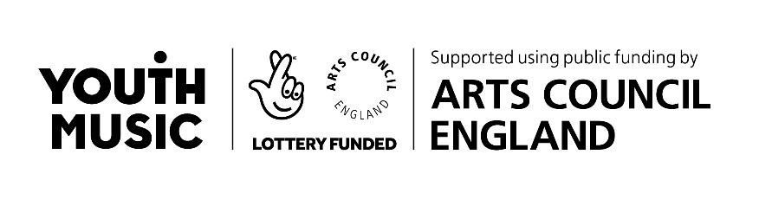
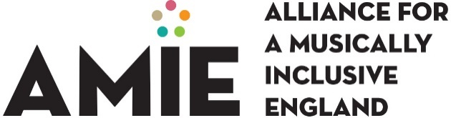

https://www.artscouncil.org.uk/children-and-young-people/music-education-hubs-survey

